
Linux System Administration (E1ITA307)
Linux Infrastructure Deployment Project Report
On
Integrated Linux Infrastructure
Submitted by
Puneeth N (2411021061259)
Singaravelan R G (2411021060346)
Bikramjeet Dey (2411021061294)
Barathidasan K (2411021061076)
In partial fulfillment of the award of the degree of
BACHELOR OF TECHNOLOGY
In
Information Technology
Under the Supervision of
Prof. U Ananthanagu

ALLIANCE SCHOOL OF ADVANCED COMPUTING
ALLIANCE UNIVERSITY
BENGALURU
Oct 2026

DEPARTMENT OF INFORMATION TECHNOLOGY
ALLIANCE SCHOOL OF ADVANCED COMPUTING

CERTIFICATE

This is to certify that the Project work entitled “Integrated Linux Infrastructure” submitted by Puneeth N (2411021061259), Singaravelan R G (2411021060346), Bikramjeet Dey (2411021061294), Barathidasan K (2411021061076) in partial fulfillment for the award of the degree of Bachelor of Technology Information Technology- IT - ARVR of Alliance University, is a bonafide work during the academic year 2026-2027.

Prof. Ananthanagu U | Prof. Ananthanagu U | Dr. Shekhar R
Course Handling Faculty | Course Coordinator | Professor & HoD

Table of Contents
1. Introduction
1.1 Aim
1.2 Background
1.3 Problem Statement
1.4 Objectives
2. Methodology
2.1 Tools and Technologies Used
2.2 Approach / Development Process
3. Linux System Administration – Design and Implementation
3.1 System Architecture
3.2 Linux Environment Setup
3.3 User and Group Management
3.4 File and Directory Management
3.5 Package and Process Management
3.6 Storage and File System Configuration
3.7 Backup and Automation
3.8 Security and Access Control
4. Results and Testing
4.1 Implementation Results
4.2 Testing and Validation
5. Conclusion and Future Scope
References
Appendices

1. Introduction
1.1 Aim
The main aim of this project is to develop an integrated Linux infrastructure system that provides efficient storage management, secure departmental access, reliable backup and recovery, and centralized system monitoring. The project is implemented using Ubuntu Server and standard Linux administration tools.
It aims to configure separate logical volumes for HR, IT, and Finance, manage user permissions using ACLs, and create backup scripts for protecting important data. Additionally, a Flask-based web dashboard is used to display system resource usage, departmental storage information, and backup details. Through this implementation, the project demonstrates practical Linux system administration concepts in a single working environment.
1.2 Background
Linux is widely used for servers because of its flexibility, security, stability, and powerful system administration tools. In a multi-department environment, proper storage allocation, permission management, and data protection are essential for maintaining reliable operations. Linux provides LVM to manage storage dynamically and ACLs to assign specific permissions to users and groups.
Bash scripting can automate repetitive administrative tasks, including backup operations and recovery procedures. Web-based monitoring tools also help administrators view important system information without manually checking every command. This project combines these technologies on Ubuntu Server to demonstrate how storage, security, backup, and monitoring can be managed together. It provides practical experience with Linux infrastructure configuration and administration.
1.3 Problem Statement
Managing departmental storage, user permissions, backups, and system resources manually can become complex and time-consuming. Without proper access control, users may access files that do not belong to their departments. Similarly, the absence of reliable backups can make data recovery difficult when files are accidentally deleted or lost.
Another challenge is monitoring storage capacity, system resources, and backup information from different locations or commands. Therefore, a structured Linux infrastructure solution is required to organize departmental storage, enforce access permissions, support data recovery, and provide a centralized view of important system information. This project addresses these challenges by integrating LVM, ACLs, Bash-based backup scripts, and a Flask monitoring dashboard.
1.4 Objectives
- To configure LVM for flexible storage management.
- To create separate logical volumes for HR, IT, and Finance departments.
- To implement ACL-based permissions for secure departmental access.
- To develop Bash scripts for full and incremental backups.
- To maintain backup copies of data and ACL permissions for recovery.
- To create a Flask-based dashboard for monitoring system resources and storage information.
- To validate access permissions and test data recovery.

2. Methodology

2.1 Tools and Technologies Used
Software
- Ubuntu Server: Used as the operating system for implementing and managing the Linux infrastructure.
- VirtualBox: Used to run Ubuntu Server in a virtual machine.
- Bash Shell: Used to execute Linux commands and develop backup scripts.
- LVM2: Used to create and manage logical volumes for HR, IT, and Finance departments.
- ACL (Access Control Lists): Used to configure departmental file and directory permissions.
- Flask: Used to create a web interface for displaying system and storage information.
- tar and gzip: Used for archive creation and data compression in backup operations.
- getfacl and setfacl: Used to view, save, and restore ACL permissions.
- Linux Terminal: Used to execute administrative commands and configure the system.
Hardware
- Laptop or desktop computer.
- Minimum 8 GB RAM recommended for running the virtual machine comfortably.
- At least 50 GB of available storage recommended.
- Hardware virtualization support enabled in BIOS/UEFI.
Other Tools
- Web Browser: Used to access the Flask monitoring dashboard.
- VirtualBox Console: Used to interact with the Ubuntu Server environment.
- Text Editor: Used to create and modify Python and Bash scripts.
- Documentation Tools: Used to prepare the technical report and project documentation.
2.2 Approach / Development Process
Step 1: Problem Identification
Identified the need for secure departmental storage, access control, reliable backups, and centralized monitoring in a Linux server environment.
Step 2: Requirement Analysis
Identified the hardware, software, storage capacity, access permissions, backup requirements, and monitoring features needed for the project.
Step 3: Linux Environment Setup
Installed and configured Ubuntu Server in VirtualBox and prepared the environment for Linux system administration.
Step 4: System Configuration
Added a 15 GB virtual disk, configured the LVM volume group and logical volumes, formatted them with the ext4 file system, and mounted the departmental directories.
Step 5: Implementation
Configured ACL-based permissions for departmental directories and developed a Flask-based dashboard to display system resources, storage details, and backup information.
Step 6: Automation
Developed a Bash script to perform full and incremental backups and created separate directories for data backups and ACL information.
Step 7: Testing
Verified logical volume configuration, departmental access permissions, backup operations, and recovery by restoring deleted test data
Step 8: Documentation
Documented the project architecture, Linux commands, storage configuration, ACL settings, backup procedures, dashboard functionality, and testing results.
3. Linux System Administration – Design and Implementation
3.1 System Architecture
The project architecture consists of an Ubuntu Server running inside VirtualBox, departmental storage managed through LVM, ACL-based access control, backup scripts, and a Flask monitoring dashboard.
System Architecture Diagram
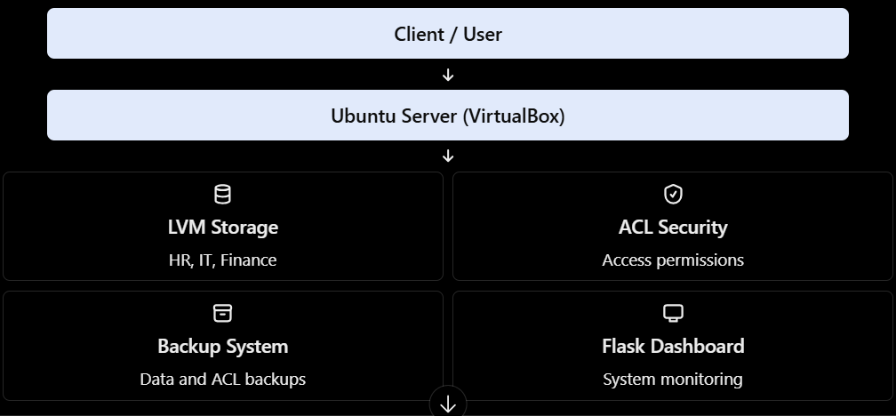

Figure No: 1 = System Architecture

The client accesses the monitoring dashboard through a web browser. Ubuntu Server manages departmental storage and permissions, while backup scripts support data recovery. The dashboard displays system resources, storage details, and backup information.

3.2 Linux Environment Setup

Ubuntu Server was installed and configured inside VirtualBox to provide a virtual Linux environment for the project. An additional 15 GB virtual disk was added for departmental storage. Python 3 and Flask were installed to develop the monitoring dashboard.

The server environment was configured using the Linux terminal, and the dashboard was made available locally through 127.0.0.1:5000.

Important commands:

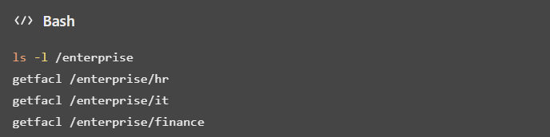

These commands help verify the system hostname, kernel information, available disks, file system usage, and Python installation.

3.3 User and Group Management

Linux file ownership and permissions help protect departmental data from unauthorized access. In this project, ACLs are used to configure access permissions for departmental directories according to user requirements.

The getfacl command displays the permissions assigned to files and directories, while setfacl is used to configure access rules.

Important commands:

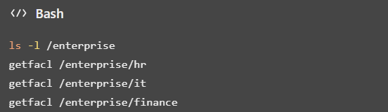

These commands help verify directory ownership and access permissions. The ACL configuration supports controlled access to HR, IT, and Finance data.

3.4 File and Directory Management

The project uses separate directories to organize departmental files, backup data, ACL information, and scripts. The directories /enterprise/hr, /enterprise/it, and /enterprise/finance store departmental data, while /enterprise/backups and /enterprise/acl_backup hold backup information.

Important commands:

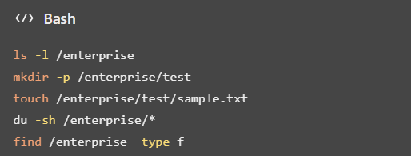

These commands demonstrate directory listing, directory creation, file creation, disk usage monitoring, and file searching. Organized directory management makes the infrastructure easier to maintain.

3.5 Package and Process Management

Package management was used to install the software required for the project. Python 3 and Flask provide the environment for running the monitoring dashboard. Linux commands can also be used to inspect processes, monitor resource usage, and manage running applications.

Important commands:

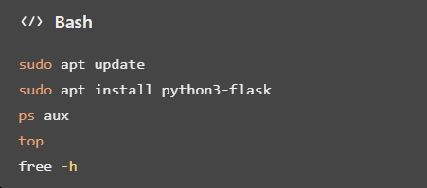

The apt commands manage software packages, ps and top display running processes, and free -h reports memory usage. These tools help maintain the Linux environment and troubleshoot application issues.

3.6 Storage and File System Configuration

An additional 15 GB virtual disk was configured using Logical Volume Manager (LVM). The volume group enterprise_vg contains logical volumes for HR, IT, and Finance. Each logical volume uses the ext4 file system and is mounted at its respective departmental directory.

The HR logical volume was also expanded by 1 GB to demonstrate flexible storage management.

Important commands:

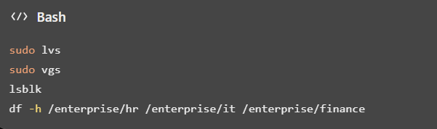

These commands display logical volumes, volume groups, disk structure, and departmental storage usage. LVM enables flexible allocation and expansion of storage as required.

3.7 Backup and Automation

A Bash script located at /enterprise/scripts/backup.sh was developed to support full and incremental backup operations. Backup data is stored in /enterprise/backups, while ACL information is maintained separately in /enterprise/acl_backup.

The recovery process was tested by restoring deleted test data and checking the saved permissions. This verifies the basic backup and recovery workflow.

Important commands:

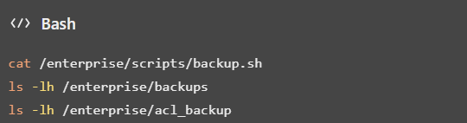

These commands display the backup script and list the available backup entries. The implemented script reduces repetitive manual work. Scheduled execution through Cron should only be documented if it has actually been configured.

3.8 Security and Access Control

Security is implemented using Linux file permissions and ACLs to control access to departmental directories. ACL information is backed up separately to support permission recovery. The monitoring dashboard displays system information and is configured to listen on 127.0.0.1:5000, limiting its direct access to the local machine.

Important commands:

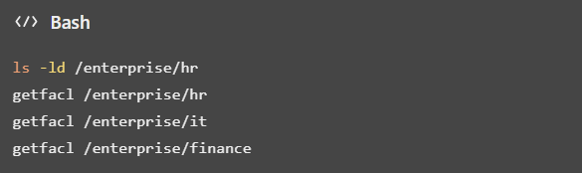

These commands help verify directory permissions and ACL rules. The project demonstrates departmental access control and permission recovery. Additional measures such as firewall rules, SSH hardening, and password policies should be described only if they have been configured and tested.

4. Results and Testing

4.1 Implementation Results

The Linux infrastructure was implemented successfully using Ubuntu Server in VirtualBox. LVM was configured with separate logical volumes for HR, IT, and Finance, and ACLs were used to manage departmental access permissions. A Bash script was developed for full and incremental backups, and ACL information was stored separately. Backup recovery was validated by restoring deleted test data. The Flask-based dashboard displays system resource usage, departmental storage information, and backup details.

Screenshots and outputs to include:

LVM configuration using sudo lvs

Departmental storage using df -h

ACL permissions using getfacl

Backup files using ls -lh /enterprise/backups

ACL backups using ls -lh /enterprise/acl_backup

Flask monitoring dashboard in the browser

4.2 Testing and Validation
Table No: 1 – Testing and Results.
Test Case | Expected Result | Actual Result | Status
LVM configuration | Logical volumes created successfully | HR, IT, and Finance volumes configured | Pass
Permission configuration | Correct access granted or denied | ACL permissions configured and checked | Pass
Package installation | Flask installed successfully | Flask installed using APT | Pass
Dashboard service | Dashboard runs successfully | Dashboard accessible locally through browser | Pass*
Backup execution | Backup files created successfully | Backup entries available in backup directory | Pass*
Data recovery | Deleted data restored successfully | Test file restored successfully | Pass
Automation | Scheduled task executes successfully | Verify Cron configuration if used | Pending verification
Security test | Unauthorized access prevented | Verify access using the configured ACL rules | Pending verification

*Use Pass only if you have verified the result during testing. Otherwise, update the status to Pending verification.

Validation summary: The project demonstrates LVM-based storage management, ACL configuration, backup and recovery, and web-based monitoring. Testing confirms the operations that were performed, while scheduled automation and unauthorized-access prevention should be marked complete only after their specific tests have been verified.

5. Conclusion and Future Scope

5.1 Conclusion

The Integrated Linux Infrastructure project provides practical experience in Linux system administration using Ubuntu Server. It implements LVM-based departmental storage, ACL-based access control, backup and recovery scripts, and a Flask-based monitoring dashboard. The project demonstrates flexible storage management, controlled file access, data recovery, and centralized system monitoring, with validation performed on the implemented components.

5.2 Future Scope

The project can be enhanced by introducing scheduled backups, automated alerts, centralized logging, stronger security mechanisms, and remote monitoring. Further improvements may include cloud-based deployment, containerization, user authentication for the dashboard, and advanced infrastructure automation to improve scalability, reliability, and security.

References

1. Canonical, Ubuntu Server Documentation. https://ubuntu.com/server/docs/



Ubuntu

2. Linux man-pages project, Linux Command Reference and Manual Pages. https://man7.org/linux/man-pages/

3. Ubuntu, Logical Volume Management (LVM) Documentation. https://ubuntu.com/server/docs/

Ubuntu

4. Ubuntu, Linux File Permissions and System Administration Documentation. https://ubuntu.com/server/docs/

Ubuntu

5. Python Software Foundation, Python 3 Documentation. https://docs.python.org/3/

6. Pallets Projects, Flask Documentation. https://flask.palletsprojects.com/en/stable/



Flask Documentation (3.1.x)

7. GNU Project, GNU Tar Manual. https://www.gnu.org/software/tar/manual/

8. Ubuntu, Bash Shell and Linux System Administration Resources. https://ubuntu.com/server/docs/

Appendices

Appendix A:

Figure No: 2 = System Architecture
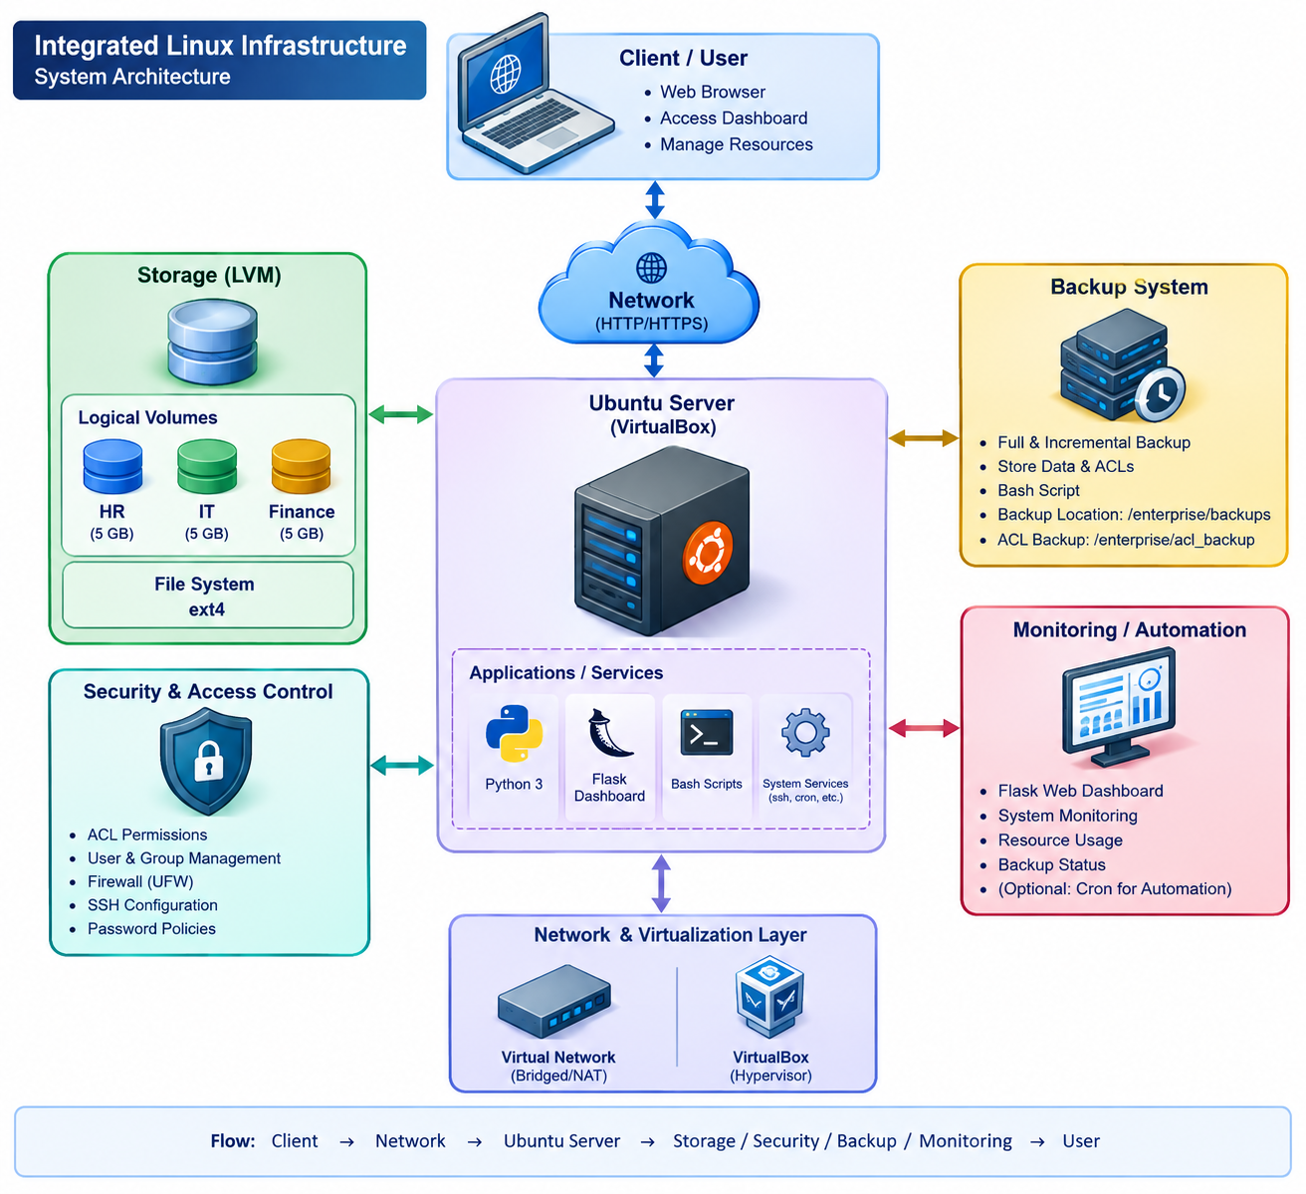

This 3D architecture diagram represents the overall design of the Integrated Linux Infrastructure project running on Ubuntu Server in VirtualBox. It shows how LVM manages separate storage for HR, IT, and Finance departments, while ACLs control access and backup scripts support data recovery. The web-based Flask dashboard monitors system resources, departmental storage, backup status, and access-control information.

Appendix B:

Figure No: 3 = Linux Commands and Configuration
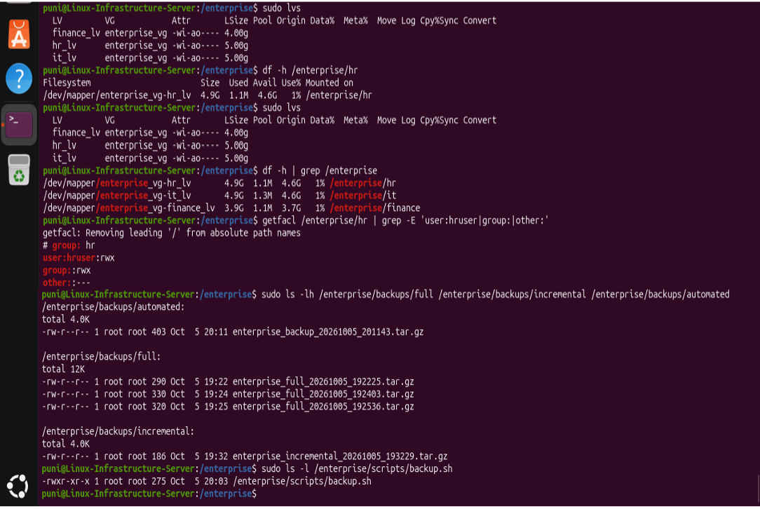

The screenshot shows the important Linux commands and configurations used in the Integrated Linux Infrastructure project. The sudo lvs command displays the logical volumes created for the HR, IT, and Finance departments. The df -h command shows the storage capacity and available space for each mounted departmental filesystem. The getfacl command verifies access permissions for the HR directory, ensuring that departmental access is controlled. The ls -lh command displays the full, incremental, and automated backup archives stored in the backup directories. Finally, the screenshot confirms that the backup.sh script exists and has executable permissions, supporting the project's data backup and recovery process.

Appendix C: Shell Scripts
The following table contains the major shell scripts and commands relevant to the Integrated Linux Infrastructure project.
Table No: 1 - Commands
S. No. | Script Name | Script / Commands | Purpose
1 | Full Backup Script | tar -czf /enterprise/backups/full/backup.tar.gz --exclude=/enterprise/backups /enterprise/hr /enterprise/it /enterprise/finance | Creates a compressed backup of departmental data.
2 | Incremental Backup | tar -czf /enterprise/backups/incremental/backup.tar.gz --newer-mtime="1 day ago" /enterprise/hr /enterprise/it /enterprise/finance | Archives files modified within the specified time period.
3 | ACL Backup | getfacl -R /enterprise/hr > /enterprise/acl_backup/hr_acl_backup.txt | Saves HR directory access permissions.
4 | ACL Restoration | sudo setfacl --restore=/enterprise/acl_backup/hr_acl_backup.txt | Restores permissions from a saved ACL file.
5 | Storage Monitoring | df -h /enterprise/hr /enterprise/it /enterprise/finance | Displays departmental storage usage.
6 | LVM Monitoring | sudo lvs | Displays logical volumes and their sizes.
7 | Backup Verification | tar -tzf /enterprise/backups/full/backup.tar.gz | Lists archive contents to check whether the archive is readable.
8 | Script Permissions | sudo chmod +x /enterprise/scripts/backup.sh | Makes the backup script executable.
9 | Execute Backup | sudo /enterprise/scripts/backup.sh | Runs the backup script.
10 | List Backup Files | ls -lh /enterprise/backups | Displays backup files and their sizes.

Explanation
These scripts and commands support backup management, ACL permission preservation, storage monitoring, and recovery operations. Full and incremental backups help organize departmental data, while ACL backup and restoration preserve access permissions. LVM and filesystem commands help monitor storage allocation and usage.
Note: The table contains representative commands, not a verified copy of every script currently implemented. Use the exact commands and script contents from your Ubuntu VM in the final report, and include only features you have tested.

Appendix D: Screenshots

Figure No: 4 - Linux installation
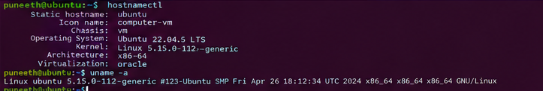

Figure No: 4.1 - User/group configuration
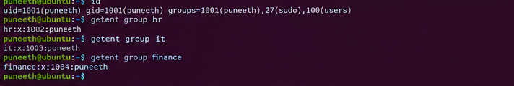

Figure No: 4.2 - File permissions
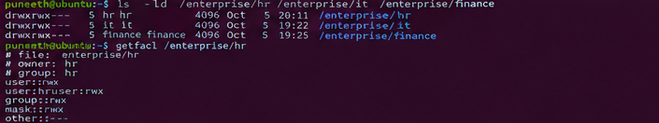

Figure No: 4.3 - Package management
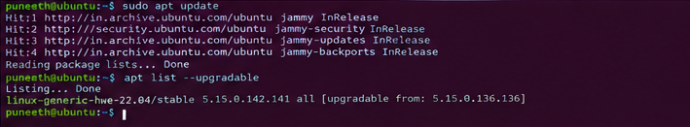

Figure No: 4.4 - Process/service management
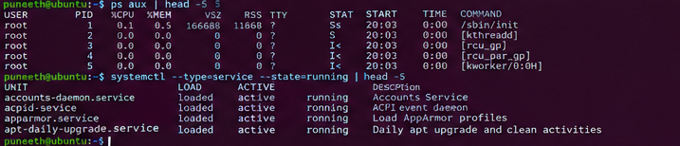

Figure No: 4.5 - Storage configuration
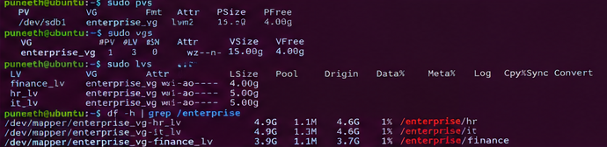

Figure No: 4.6 - Backup
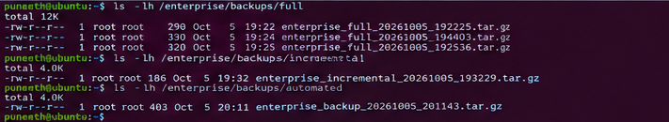

Figure No: 4.7 - Automation/Cron
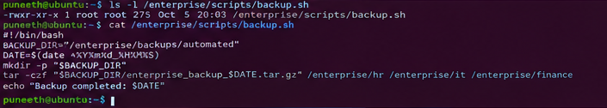

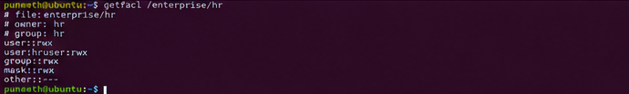
Figure No: 4.8 - Security configuration

Figure No: 4.9 - Final system out
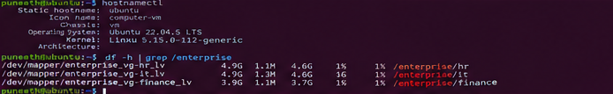

Appendix E: Testing Results

Figure No: 5 - System Overview
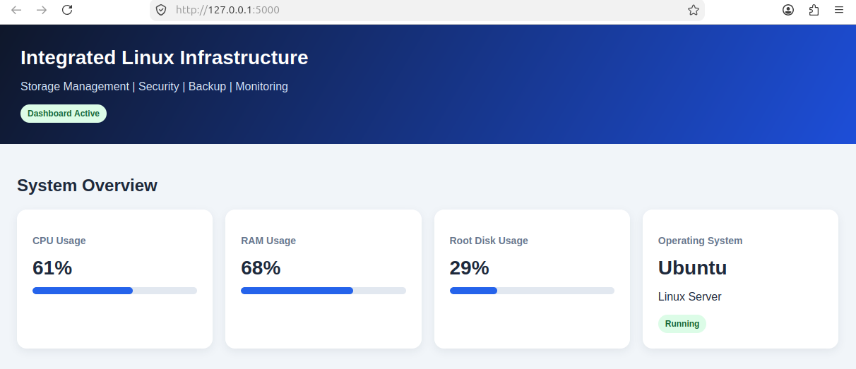

This section displays the overall status of the Linux server. CPU usage shows the processor utilization, RAM usage indicates memory consumption, and root disk usage displays the storage used by the operating system. The operating system card identifies Ubuntu Linux Server and shows its running status.
Figure No: 5.1- Infrastructure Information
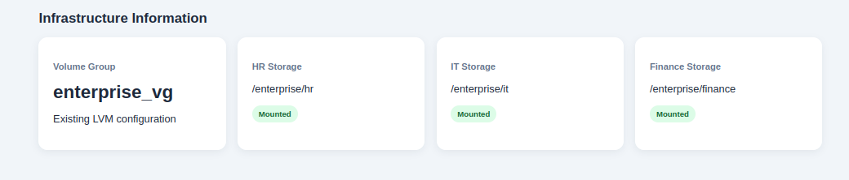

This section displays the LVM volume group named enterprise_vg and the mount points configured for HR, IT, and Finance. The green Mounted indicators show that the departmental storage locations are mounted and available according to the dashboard.

Figure No: 5.2 - Department Storage Management
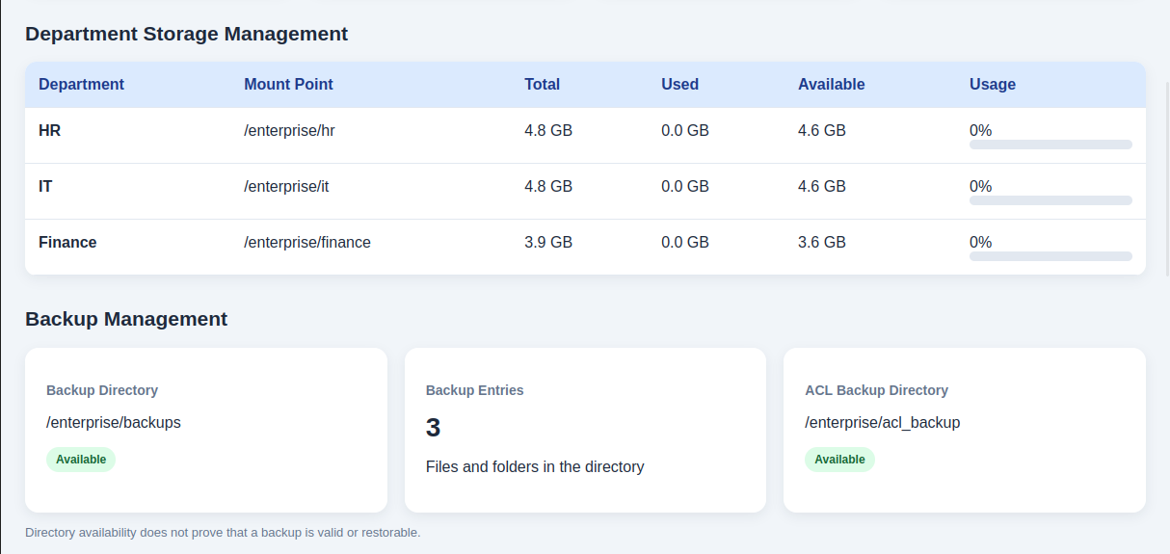

This section displays storage information for the HR, IT, and Finance departments. It shows each department's mount point, total storage, used space, available space, and usage percentage. This helps the administrator monitor storage allocation and identify departments that may need additional capacity.

Figure No: 5.3 - Backup Management
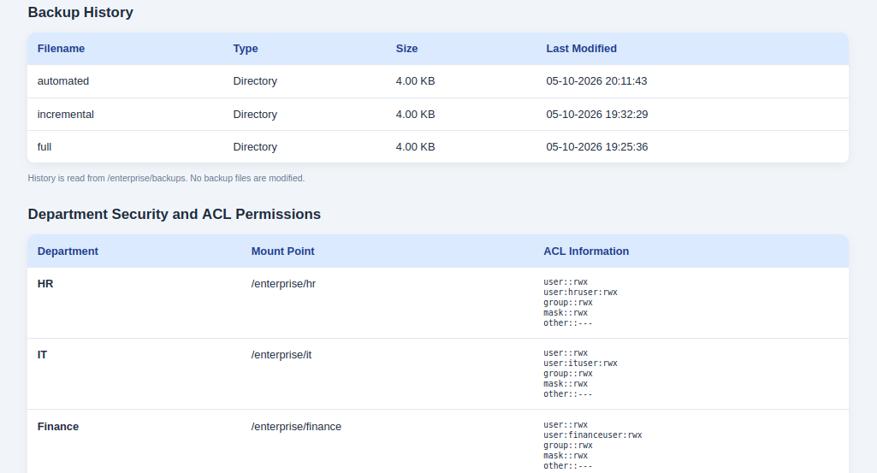

This section displays the backup directory location, the number of files and folders found in the directory, and the availability of the ACL backup directory. It helps the administrator check whether the backup locations are accessible. Directory availability alone does not confirm that backups are valid or recoverable.

Appendix F: Project Repository

Puni2727/Linux-Administration-Mini-Project

